Coaching the generations
APPA Institute for Facilities Management – February 2020

Jamie K. Gayer, PHR, SHRM-CP
Assistant Vice President, Business Services
Capital Planning & Facilities, Indiana University
Tel: 812-856-0716
jkgayer@iu.edu

Credit(s) earned on completion of this course will be reported to American Institute of Architects (AIA) Continuing Education Session (CES) for AIA members.

Certificates of Completion for both AIA members and non-AIA members are available upon request.

This course is registered with AIA CES for continuing professional education. As such, it does not include content that may be deemed or construed to be an approval or endorsement by the AIA of any material of construction or any method or manner of handling, using, distributing, or dealing in any material or product.

Questions related to specific materials, methods, and services will be addressed at the conclusion of this presentation.
WHAT IS A GENERATION?
Generation: A group of generally contemporaneous (originating, existing, or happening at the same period of time) individuals regarded as having common cultural or social characteristics and attitudes.

The Generations…Who is Involved
“…unless we accept the fact that we are making decisions every day about people we may not understand – people who may not share our basic assumptions about the world, people whose life experience has been very different from our own – unless we understand that, we risk making mistakes that can cost us dearly.”
– Karen Ritchie, Marketing to Generation X

Generation | Birth Years | Age in 2019 | Population
Traditional/Silent | 1927-1945 | 74-92 | 39.9 million
Baby Boomers | 1946-1964 | 55-73 | 75.4 million
Generation X | 1965-1976 | 43-54 | 54 million
Millennials | 1977-1997 | 22-42 | 83.1 million
Generation Z | 1998-2009 | 10-21 | 61.7 million

Group Exercise

What does your current workplace look like?

Let’s talk about Generational Values
According to Morris Massey, differences in what the different generations’ value is based upon how values were developed (programmed). He determined that values are generally programmed around the age of 10. Because people within the same age range tend to experience the same political, social, economic times, people tend to develop similar characteristics and values.

Values Snapshots

Group Exercise

So what do generational values

have to do with working together?

Examples of Generational Considerations
Traditional/silent
- Directive leadership style which was standard operating procedure. Were expected to take charge, delegate, and make the bulk of decisions themselves.
- Make strong team members as they grew up in the WWII aftermath and saw the power of labor unions and collective action in the workplace.
- Work best in structured teams that have strong direction on “the how and when to do things.”
- Can challenge younger managers by holding onto the “we have never done it this way” mentality.
- Technology can be intimidating – did not grow up with it.

- Several themes of the Traditionals are: strict adherence to rules and directives, respect for the role of authority, loyalty to organization, belief in seniority and time served.
Baby Boomers
- The “Baby Boom” was the great expansion and push toward individualism over team work in the workplace. Loyal to career first, employer second.
- Seen as the generation of achievement, concerned with raising fortunes and finding ways to achieve status, prestige, and power. Think 50-60 hour standard work week.
- Large push towards self-actualization in this generation. Shifted away from values of conformity and loyalty in previous generation to a means of self-expression and self-actualization. Think civil rights activism, Vietnam War and inflation.
- Most educated compared to other generations.
- Willing to challenge the status quo and with strong ability to handle a crisis.

- Several themes of the Baby Boomers are: value hard work demonstrated by long hours on the job, value education and high quality work products, emphasis on teamwork with regular face-to-face meetings.
Generation X
- Living in the shadow of the Boomers, this generation has passively resisted anything the older generation stood for.
- Learned that work offers no permanent guarantee for employment. Corporations can terminate you without warning, apologies, or logic.
- Prevailing attitude of “it’s just a job”. While this attitude is unlikely to change drastically, can be motivated to do a good job if presented with flexibility, technology, multitasking, feedback, and evenly disseminated recognition.
- This generation doesn’t automatically respect people because they are older. They feel that people must prove that they are worthy of respect.
- Generation X grew up with information technology. They are comfortable with sound-bites, close-up cameras, and quick changing, sharp images. They like advertising that has attitude. They like to read copy that uses short, snappy phrases, charts, diagrams, and cartoons. They want their information concrete, concise, and to the point.
- Gen Xers watched their grandparents work long hours only to receive a gold watch and pension upon retirement. Then their parents’ dedication to the company was repaid with downsizing and layoffs.

- Several themes of the Gen X’s are: independent, resourceful, self-sufficient, value freedom and responsibility in the workplace, can display casual disdain for authority and structured work hours, demand high productivity and prefer to get tasks done quickly, embrace a hands-off management philosophy.

Millennials
- Grew up with parents that paid close attention to every facet of child rearing in an all-out pursuit of bringing up well-educated, well-adjusted children…think “helicopter parents”.
- Grew up in an era of drastic technology change…think corded house phone to smartphone.
- Early Millennials are likely to subscribe to a stricter moral code as their parents have been vigilant in insisting that they use “please”, “thank you”, “sir”, and “ma’am”.
- The everyone wins…Trophy Generation.

- Several themes of the Millennials are: tech-savvy, family-centric, team-oriented and want to be included, require attention and feedback, achievement oriented, free expression and aren’t afraid to question authority, strong views, innovation, civic minded and critical thinkers.
Generation Z
- Gen Z does not know a time without technology; they are “digitally entrenched”. Spend 6 to 9 hrs a day absorbing media; 92% are online daily.
  - 85% of Gen Z watched at least one online video in the past week to learn a new skill.
- Technology has taught them to be super multi-taskers. Need constant stimulation to stay engaged.
- Do not rely on their parents as much as previous teen generations. Earning their own spending money through freelance work, a part time job, or earned allowance.
- Most excited to apply for jobs with a fun work environment (47%) and flexible work schedule (44%).
- The pendulum is swinging back from the Millennials’ “college debt is a part of life” mentality. Over 1 in 5 members of Gen Z say that personal debt should be avoided at all costs.
  - Want to learn now and work now, delaying work for four years is less than ideal.
  - Apprenticeships are becoming the labor of choice as getting paid to learn is a viable offer.

- Several themes of the Gen Z’s are: being independent, self-confident and autonomous, very environmentally aware, short attention span and need visual stimulation. Able to multitask given their ability to process and absorb information so quickly.

Group Exercise

How does understanding differences help in building an inclusive work environment?

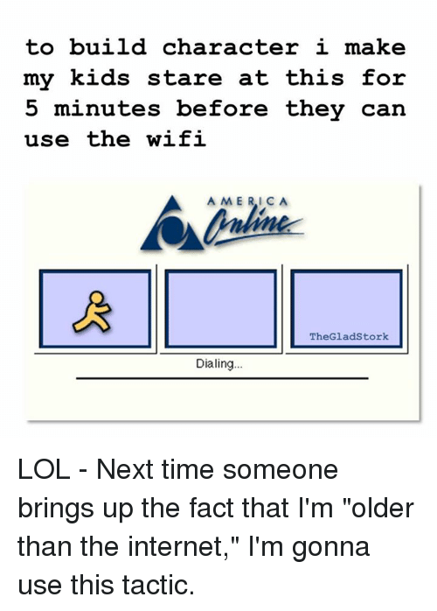

Understanding the Field of Play

 | Traditionals | Boomers | Gen Xers | Millennials | Gen Z
Defining Values | Loyalty | Optimism | Skepticism | Realism | Authenticity
Communication Style | Discrete | Diplomatic --  In-person | Blunt and Direct | Polite but Direct | Collaborative
Communication Method | Write a Memo | Call Anytime | Call only while at Work | Email or Text Anytime | Social Media 24/7
Relation to Authority | Respectful | Antagonistic | Love/hate | Relaxed | Trustful…to an extent
Career Goals | Build a legacy | Build a stellar career | Build a portable career | Build parallel careers | Build a better tomorrow
View of Technology | Adapted  Think party lines and radios | Acquired  Think TV growth | Assimilated  Think computer revolution | Integral  Think Internet explosion | Native  Think A.I.  Siri & Alexa
Dislikes at Work | Change --  Ambiguity | Lack of diversity | Micro management | Menial Work | Distance -- Structure
Viewpoint on Rewards | Satisfied with a job well done | Money, title & recognition | Freedom in work is the ultimate reward | Meaningful work with recognition for input | Reward me by growing me
Viewpoint on Work/Life Balance | Work Hard  Work and home are separate things | Live to Work  Hesitant to take time off | Work to Live  Clearer focus on taking time off | Work isn’t Everything  Flexibility to balance all activities | Work is Fun  Flexible, fun, and group oriented…

Group Exercise

What does it mean to ‘coach’ someone in the workplace?

Knowing How and When to Give Feedback & Provide Learning Opportunities

 | Feedback | Training/Learning
Traditional | No news is good news  Subtle, private recognition…no fanfare | - I learned the hard way, you can too!  - Happens on the job  - Skills are for organization, not individual
Baby Boomers | Expect an annual review  If not in alignment, be sure to have lots of documentation. | - Formal, structured learning but expect interaction  - Training is important but not as important as work ethic and time in the job
Generation X | Sorry to interrupt, but how am I doing?  Quarterly feedback is fine | - Increased skill leads to next job, either within or external  - Self-directed learning is preferred  - Skills are more important that work ethic
Millennials –  Gen Y | Crave frequent feedback  Prefer with regularity (weekly/monthly)  More likely to comply when provided with rationale | - Continual learners, innovative and collaborative  - Prefer less formal learning environments with lots of interaction  - Motivated by seeing immediate results from training – outcomes have to be relevant
Generation Z | Coach me continuously  “Bites” of feedback at all times | - Learning is constant, digital and can be found anywhere  - Training tools need to be visually stimulating to retain attention  - Need understanding of purpose of training and how development in role helps organization achieve mission to help society

Aligning Across Generations – Where are the Fault Lines?
“By 2020, 13 million more Boomers will have retired, Millennials will dominate the workplace in terms of sheer numbers, Gen X will own the C-suite, and 30 million Gen Zs will have come to work. We are watching the workplace and the work ethic shaped by Boomer values dissolve rapidly as Millennial values take hold.” (3 New Generation Realities, Amy Lynch)

Food for Thought…Questions asked of Gen Z students

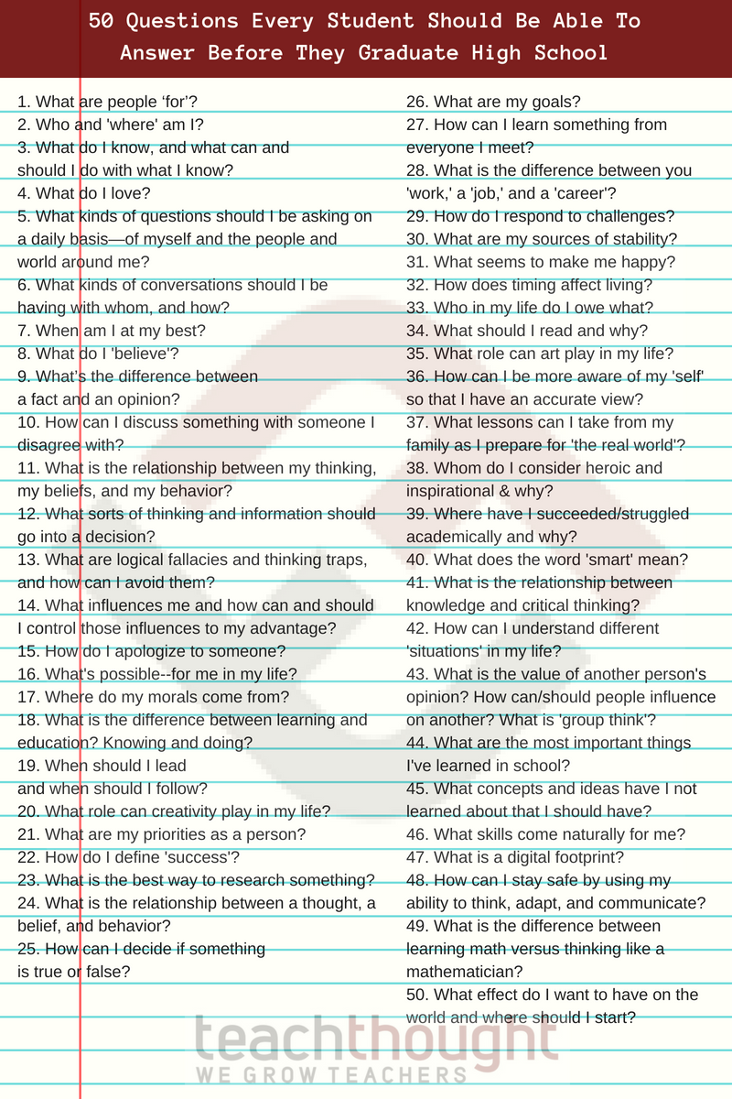

https://www.teachthought.com/critical-thinking/questions-every-student-should-be-able-to-answer-before-they-graduate-high-school/

To Get the Most from Millennials (and Everyone Else) Know the Right Approach:

 | Career Development | Mentoring Approach
Traditional | Not really an option…keep nose to the grindstone and will advance eventually | - Respect their experience and find ways to use their testimonials  - Ask what approach works best and adapt accordingly
Baby Boomers | Seniority = Advancement  Tend to stay within org and/or industry | - Must know they are valued part of team and their role is important  - Understand comfort level with technology before starting new projects  - Appreciation upfront for time with organization and that they have ‘paid their dues’
Generation X | Proactive growth through degrees and licensure  Will leave org if experiences do not match expectations | - Allow flexibility to be creative and set own pace  - Understand that they choose to work with you, not for you  - Be prepared to answer “why” often  - Follow through is critical, do not leave open-ended
Millennials –  Gen Y | Looking for a variety of experiences  Will search for this within org first before seeking it elsewhere  Provide learning opportunities in multiple formats (on-job, in person class, online, etc) | - Establish formal mentor programs and involve them up front  - Encourage new avenues through structured ‘rule-breaking’  - Spend time providing guidance and then challenge them to set specific achievable goals
Generation Z | Looking for immediate opportunities for advancement and wage increases  Will job hop quickly in order to achieve this in time period they feel is appropriate | - Take genuine interest in learning who they are and where they want to go  - Remember they are wide eyed about workplace realities, guide gently through

Get out of your Comfort Zone

to be a good mentor
Recognize that the advice you give almost always reflects YOUR generation…

- Approach everyone differently

- Set expectations up front and together

- Know when to wait to give advice

- Don’t assume anything -- Ask

- Acknowledge mistakes you’ve made

- Celebrate achievements

- Look for or create situations to involve them in

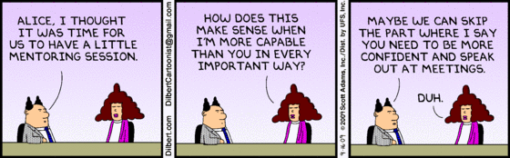

“Tell me and I forget, teach me and I may remember, involve me and I learn.”

-- Benjamin Franklin

Aligning Across Generations – What Works Where

 |  |  | Communication/ Professionalism |  | Work Environment
Traditionals |  | Formal communication: memos, formal tone, good grammar & diction, no profanity  Like personal interaction, handwritten notes |  | - Conservative and hierarchal  - Clear chain of command
Baby Boomers |  | Semi-formal communication: face-to-face, phone call, body language is important  Like personal touch from management |  | - “Flat” hierarchy  - Democratic decision making  - Equal opportunity to be heard
Generation X |  | Direct and immediate communication: Email (#1 preference), cell phones, texting  Use straightforward language with no jargon or buzz words |  | - Informal…what’s a hierarchy?  - Flexible and adaptable to change  - Easy access to leadership
Generation Y/ Millennials |  | Relaxed communication: text, social media not focused on grammar, relaxed, informal, emojis,– don’t forget the hashtag!  Communicate in person if important |  | - Informal though need to know who is in charge  - Flexible and adaptable to creativity and fun  - Collaborative decision making
Generation Z |  | Return to face to face communication but with hand held devices- Facetime, Lync, Skype, GIF’s |  | - Work from anywhere, at any time  - Technology enabled productivity

Having people who were born between the 1940s and the 2000s work together creates the potential for creativity and innovation, but also for conflict and misunderstanding.

You can avoid pitfalls and ensure inclusivity by:
- Staying respectful, flexible and understanding.
- Avoiding stereotypes.
- Being open to learning from others, and helping them to learn from you.
- Adapting your communication style.
- Focusing on similarities between individuals, rather than on generational differences.

Where Generations Align

Flexible Schedules
- Baby Boomers (94%) and Millennials (74%) report they want flexible work schedules and telecommuting.

- With the shift from work-life balance to work-life integration, all generations are trending towards creating work arrangements that align well with other life priorities.
HOW CAN YOU SUPPORT FLEXIBILITY IN A FACILITIES ENVIRONMENT??

Making an Impact
- The IBM Institute for Business Value reports that a top career goal of Gen Z, Millennials, Gen X, and Baby Boomers alike is “making an impact.”

- Everyone is interested in making a difference for their organization. Empower your employees of all ages to do so.
HOW DOES YOUR STAFF KNOW THEY ARE HAVING AN IMPACT ON CAMPUS?

Motivation
- Financial Incentives are motivators for Traditionalists/Baby Boomers/Generation Z while Time Off is the common motivator for Gen X and Y.

- Employees of all generations, not just Millennials, report that the best way to motivate them is to recognize them sincerely for a job well done. This creates an emotional connection between employer & employee.

A simple, genuine thank you is the best motivator of all.
WHEN IS THE LAST TIME YOU HEARD THANK YOU or SAID IT YOURSELF?

Resources
- Clash of the Generations- Managing the New Workplace Reality, 2017 Valerie Grub

- TedxHouston Talk by Jason Dorsey, What do we know about the generation after millennials? https://youtu.be/4f16o9Q0XGE

- The State of Gen Z 2017 White Paper. 2017. The Center for Generational Kinetics: http://genhq.com/gen-z-2017-research-white-paper/

- How to get along with Boomers, GenXers and Millennials | Mary Donohue | TEDxToronto https://www.youtube.com/watch?v=RtDxPcQ8GJg

- 38 Killer Strategies You Can Use to Crush Generational Conflict Now! – eBook - http://www.generationaledge.com/alert

- 2016 Deloitte Millennial Survey: https://www2.deloitte.com/content/dam/Deloitte/at/Documents/human-capital/millennial-innovation-survey-2016.pdf

- Luke Wilson on Conan O’Brien, September 20, 2017 – Millennials in Airports: https://www.youtube.com/watch?v=pkoMfqJnLBA&sns=em

- Generation Z: 12 Important Things Companies Need To Understand, March 2017: https://www.forbes.com/sites/forbescoachescouncil/2017/03/03/generation-z-12-important-things-companies-need-to-understand/#60bcfb4f1fe3

- Managing Across Generations, May 2017 Carolyn Goerner, PHD
https://iu.mediaspace.kaltura.com/media/Managing+Across+Generations/1_o8vz39v3/63189421

- Where Perspectives Align: https://www.forbes.com/sites/davidsturt/2016/08/16/generational-differences-when-they-matter-and-when-they-dont/2/#69a4c54e64df

- Employee Motivation 2019: https://www.snacknation.com/blog/how-to-motivate-employees/

- From Catalyst: http://www.catalyst.org/knowledge/generations-demographic-trends-population-and-workforce

- From: https://www.census.gov/newsroom/press-releases/2018/cb18-41-population-projections.html

- From: Pew Research Center: http://www.pewresearch.org/fact-tank/2018/04/11/millennials-largest-generation-us-labor-force/

- From: http://genhq.com/gen-z-2017-research-white-paper/

- Generation Z in the Workplace: 5 Ways to be a better employer: www.staffbase.com/blog

This concludes The American Institute of Architects Continuing Education Systems Course.

