Documentation of UW-Milwaukee’s Classroom Capacity Calculation to Implement Social Distancing Practices

In observance of the Center for Disease Controls *Considerations for Institutes of Higher Education* which recommends maintaining approximately 6’ of space between individuals to minimize spread of the disease, the University of Wisconsin – Milwaukee intends to utilize an 8’ diameter “social distance safety bubble” to diagram and forecast classroom capacities. The 6’ social distance bubble is measured from the outside of the body so allowances must be made for body-width.

The shoulders are typically the widest part of a human’s body. Anatomy data from a [1998 study conducted by North Carolina University’s Ergonomic Center](https://multisite.eos.ncsu.edu/www-ergocenter-ncsu-edu/wp-content/uploads/sites/18/2016/06/Anthropometric-Detailed-Data-Tables.pdf), found the average forearm-to-forearm breadth of males to be 21.5 inches. Please see diagram below. To extend beyond 24”, an individual would need to be in the 95th percentile for males and over the 99th percentile for females.

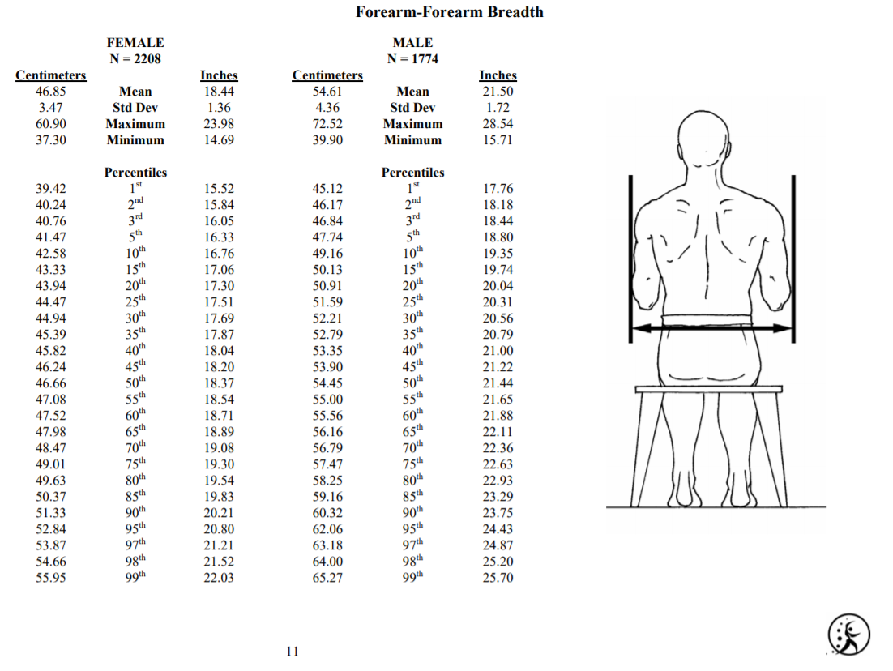

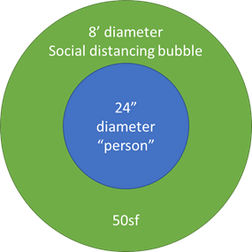Additionally, in consideration of those whom, due to body weight, might have a larger waistline than shoulder width, an individual would need to exhibit a 75” waist circumference to meet the 24” diameter body limit of our model.

In consideration of that data and with a goal of meeting the CDC recommendation of maintaining a 6’ separation between individuals, an 8’ diameter circle has been determined to meet safety protocols.

Applying this spacing model to test-fit drawing examples of typical UW-Milwaukee classroom types, the following factors have been applied to UWM’s General Assignment Classroom inventory to forecast adjusted room capacities:

|  |  |
| --- | --- |
| **Furniture Type** | **Recommended SF/Occupant** |
| Moveable Seating (Chairs only or Tablet Arm Chairs) | 65 |
| Fixed Table Arm Seats (Lecture/Theater Style) | 115 |
| Fixed Tables/Chairs | 120 |
| FixedTable/MovableChair | 120 |

The application of these factors produces a predictive GA Classroom inventory of:

It should be emphasized, these figures are for general planning purposes and once a determination is made for diameter of the social distancing bubble, specific capacities will be developed for each classroom.